# PROFESSIONAL TRAINING REPORT

**at**

**Sathyabama Institute of Science and Technology (Deemed to be University)**

Submitted in partial fulfillment of the requirements for the award of Bachelor of Engineering Degree in Computer Science and Engineering

By

**Name - Rajeev Nayan**

**Reg no. - 39110828**



# DEPARTMENT OF COMPUTER SCIENCE AND ENGINEERING SCHOOL OF COMPUTING

**SATHYABAMA INSTITUTE OF SCIENCE AND TECHNOLOGY JEPPIAAR NAGAR, RAJIV GANDHI SALAI,**

**CHENNAI – 600119, TAMILNADU**

**NOVEMBER - 2021**

SATHYABAMA

**INSTITUTE OF SCIENCE AND TECHNOLOGY**

**(DEEMED TO BE UNIVERSITY)**

## Accredited with Grade “A” by NAAC

**(Established under Section 3 of UGC Act, 1956)**

**JEPPIAAR NAGAR, RAJIV GANDHI SALAI, CHENNAI– 600119**

**[www.sathyabamauniversity.ac.in](http://www.sathyabamauniversity.ac.in/)**

**DEPARTEMENT OF COMPUTER SCIENCE AND ENGINEERING**

**BONAFIDE CERTIFICATE**

This is to certify that this Project Report is the bonafide work of **Rajeev Nayan (39110828)** who carried out the project entitled **“Pneumonia detection using X-ray images”** under my supervision from August 2021 to October 2021.

**INTERNAL GUIDE:**

**Name: Dr. S.L. Jany Shabu**

**HEAD OF DEPARTMENT**

**Dr. L. LAKSHMANAN M.E., Ph.D.,**

**Dr.S.VIGNESHWARI, M.E., Ph.D.,**

**Submitted for Viva Voice Examination held on**

**Internal Examiner External Examiner**

# DECLARATION

**Rajeev Nayan** hereby declare that the Project Report entitled ‘**Pneumonia detection using X-ray images** done by me under the guidance of **Dr. S.L. Jany Shabu** and **Dr. L. LAKSHMANAN M.E., Ph.D., and Dr.S.VIGNESHWARI, M.E.,Ph.D.,**at Sathyabama Institute of Science and Technology is submitted in partial fulfillment of the requirements for the award of Bachelor of Engineering degree in Computer Science and Engineering.

## DATE: Rajeev Nayan

**PLACE:**CHENNAI **SIGNATURE OF THECANDIDATE**

## ACKNOWLEDGEMENT

I am pleased to acknowledge my sincere thanks to **Board of Management** of **SATHYABAMA** for their kind encouragement in doing this project and for completing it successfully. I am grateful to them.

I convey my thanks to **Dr. T. Sasikala M.E., Ph.D.**, **Dean**, School of Computing, **Dr.S.Vigneshwari M.E., Ph.D., and Dr. L. Lakshmanan M.E., Ph.D.,** Heads of the Department of Computer Science and Engineering for providing me necessary support and details at the right time during the progressive reviews.

I would like to express my sincere and deep sense of gratitude to my Project Guide **Dr. S.L. Jany Shabu** for her valuable guidance, suggestions and constant encouragement paved way for the successful completion of my project work.

I wish to express my thanks to all Teaching and Non-teaching staff members of the **Department of Computer Science and engineering** who were helpful lin many ways for the completion of the project

**ABSTRACT**

The Project “Pneumonia Detection using chest x-rays” uses deep learning convolution neural network algorithm to detect whether the x-ray provided to the model is diagnosed with pneumonia or not.

To do this all sort of building deep learning models we need data, The data for this project is in form of images. The dataset has been taken from kaggle website.

Do implement this project we need an environment like Jupyter notebook or Google collab.

I have used google collab for preparing the data and training the CNN model as when I was using Jupyter notebook my system was crashing as it requires high end GPU.Then after training the model I saved the model and downloaded the files in my system.

Dataset contains two different labeled data one for Normal (not pneumonia) and other for Pneumonia.The total data was 7217 chest x-ray images.

## TABLE OF CONTENTS:

|  |  |  |
| --- | --- | --- |
| **Chapter No.** | **Title.**  Abstract  List of Figures  List of Abbreviations | **Page No.** |
| **1.** | **INTRODUCTION**   * 1. INTRODUCTION TO PNEUMONIA DISEASE.   2. INTRODUCTION TO DEEP LEARNING   3. PNEUMONIA DETECTION USING X-RAY IMAGES | 9  10  10 |
| **2.** | **AIM AND SCOPE OF THE PRESENT INVESTIGATION** | 11 |
| **3.** | **EXPERIMENTS OR REQUIRMENTS AND METHODS USED**  3.1. PROJECT DESCRIPTION  3.2 METHODS USED | 13  13 |
| **4.** | **RESULTS AND DISCUSION, PERFORMANCE ANALYSIS** | 14 |
| **5** | **SUMMARY AND CONCLUSION**  **REFERENCES**  A. SOURCE CODE  B. SCREEN SHOTS | 15 |

## LIST OF FIGURES

|  |  |  |
| --- | --- | --- |
| **FIGURE NO.** | **FIGURE NAME.** | **PAGE NO.** |
| **6.1**  **6.2**  **6.3**  **6.4**  **6.5**  **6.6** | **NORMAL CHEST X-RAY IMAGE**  **PNEUMONIA CHEST X-RAY IMAGE**  **DISTRIBUTION OF DATASET**  **LINE PLOT OF LOSS**  **LINE PLOT OF ACCURACY**  **LOSS AND ACCURACY** | 16  16  17  17  18  18 |

**CHAPTER 1**

1. **INTRODUCTION**

**1.1 Introduction to the PNEUMONIA DISEASE:**

Pneumonia is an infection that inflames the air sacs in one or both lungs.The air sacs may fill with fluid or pus (purulent material), causing cough with phlegm,ever, and difficulty breathing.

A variety of organisms, including bacteria, viruses and fungi, can cause pneumonia.

Pneumonia can range in seriousness from mild to life-threatening. It is most serious for infants and young children, people older than age 65, and people with health problems or weakened immune systems.

Symptoms of Pneumonia :

* Chest pain when you breathe or cough
* Confusion or changes in mental awareness (in adults age 65 and older)
* Cough, which may produce phlegm
* Fatigue
* Fever, sweating and shaking chills
* Lower than normal body temperature (in adults older than age 65 and people with weak immune systems)
* Nausea, vomiting or diarrhea
* Shortness of breath

Newborns and infants may not show any sign of the infection. Or they may vomit, have a fever and cough, appear restless or tired and without energy, or have difficulty breathing and eating.

The only way to get prevented of pneumonia is to breathe fresh air, wash hands regularly on daily basis to get rid off bacteria.

Chest X-ray, blood tests, and culture of the sputum may help to confirm the Pneumonia affected person.

## 1.2 Introduction to Deep Learning :

Deep learning is a sub part of machine learning and machine learning is part of Artificial Intelligence. Artificial Intelligence is a general term that refers to techniques that enable computers to learn human behavior.

Machine Learning represents a set of algorithms trained on large amount of data that make all of this possible.

Deep learning also uses algorithm to train large amount of data and draw similar conclusions as humans.

To achieve this, deep learning uses multi layered structure of algorithms called neural networks.

The design of the neural network is based on the structure of the human brain. Just as we use our brains to identify patterns and classify different types of information, neural networks can be taught to perform the same tasks on data.

**Neural networks enable us to perform many tasks, such as clustering, classification or regression.**

## 1.3 Pneumonia Detection using X-Ray images

**Since, we know that Pneumonia can be detected by Chest X-Rays, that is doctors see the x-ray and say whether the person is suffering with Pneumonia or not .**

Therefore deep learning uses the same concept, it visualizes the x-ray image passed to it and make a decision .

**For making a decision and that also correct decision the deep learning model is trained on large number of X-ray images of two categories Pneumonia and Normal ,**

**so that the model can visualize the features of Pneumonia affected person x-ray and make a correct decision with high accuracy.**

## CHAPTER 2

**AIM AND SCOPE OF THE PRESENT INVESTIGATION**

**AIM:** To build a binary classifier to detect pneumonia using chest x-rays.

**SCOPE:** The classifier would be used to differentiate Pneumonia diagnosed person chest x-ray image and Normal person chest x-ray image.

Since it is using deep learning technology the result would be delivered fast and efficient.

This technology can be used in health care , hospitals to save the time of doctors so that they could be available for other patients.

Before using this technology in health care departments the deep learning model should be trained on large number of data (in lakh) and attain good accuracy.

**CHAPTER 3**

**REQUIREMENTS AND METHODS**

## SYSTEM SPECIFICATION

**Hardware Requirements:**

1. Processor – Intel Core processors or any AMD chips.
2. GPU – High end Graphics
3. RAM >=8 GB
4. Hard Disk >=256GB
5. Mouse – Standard Mouse
6. Keyboard – Logitech Keyboard
7. Processor Speed – 2.4GHZ

## Display Mode:

1. Color Quality – Highest[32bit]
2. Screen Resolution – 1024 by 768Pixels

**Software requirements:**

1. Jupyter Notebook and Google Collab.
2. Python 3 or latest version.
3. VS-code

**3.1 PROJECT DESCRIPTION:**

In this project, I have designed convolution neural network and trained the neural network with chest x-ray images of Pneumonia diagnosed person and Normal person,and using that neural network model to detect the chest x-ray of person whether he/she is suffering from Pneumonia or not .

**3.2 METHODS USED:**

1. Convolution Neural Network Architecture

The Neural Network consist of three convolution layer and each layer consist of pooling layer and dropout layer. The Neural Network Model is trained on fifteen epochs .

Initially the dataset was imbalance , the Normal data was 1341 and the Pneumonia data was 3875 . So i did Data Augmentation on the Normal Data to overcome the over fitting problem. Now the Normal Data became around 3342 which is good to go with. Then some pre-processing of data which is chest x-ray images is done , such as resizing and adding label to each images , the label 0 is for Normal and 1 is for Pneumonia. Then the data is splitted into Features and Target variable X and Y respectively. The target is label 0 and 1 , and the feature is the image converted to numpy array. Then Normalization (X/255) is done on the X variable to decrease the computational work. After preparing the dataset the dataset is passed in the neural network model to train the model.

**CHAPTER 4**

**RESULT AND DISCUSSION**

**RESULT:** In this project we have used deep learning Convolution Neural Network model to classify the chest x-ray images in two different categories Pneumonia diagnosed and Normal.

**PERFORMANCE** **ANALYSIS**:

The Convolution Neural Network Model with three Convolution layer each consisting of pooling layer and dropout layer and the activation function used in each layer is relu . The Accuracy and loss of the model are :

***Accuracy:***

Training and validation both accuracy is being increased together which shows model is a good fit. The training and validation both accuracy comes out to be 97.64 and 97.23 percent respectively.

***Loss:***

Training and validation both losses is being decreased together which shows the model is good fit.The training and validation both loss comes out to be 0.0682 and 0.0689 respectively.

**CHAPTER 5**

**SUMMARY AND CONCLUSION**

This project classifies the person x-ray whether its Pneumonia diagnosed or not.

We cannot guarantee that this is 100% accurate because there are several circumstances in which person is diagnosed with pneumonia.

Since this is a project for health care , so the model should be trained on millions of data to get a good accuracy and to use this tool in health care.

This can be used to examine and anybody can use this to check if they are diagnosed or not , since its just require chest x-ray and gives the output in a second.

**FUTURE RESEARCH**

In this project i have only used few convolution neural network and whichever gave me best and high accuracy i have used that model to train the data.

We can use more other methods such as Vgg , DenseNet, InceptionNet , etc , to train the model and improve the accuracy and loss.

1. **LIST OF IMAGES**

**6.1 NORMAL CHEST X-RAY**

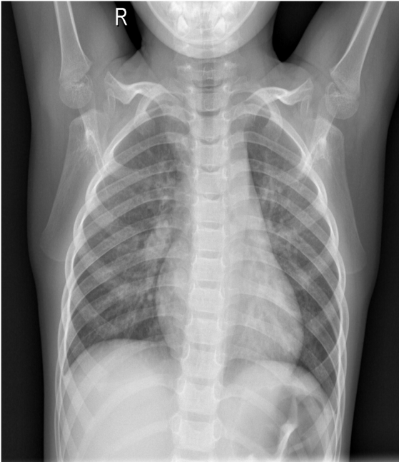

**6.2 PNEUMONIA DIAGNOSED CHEST X-RAY**

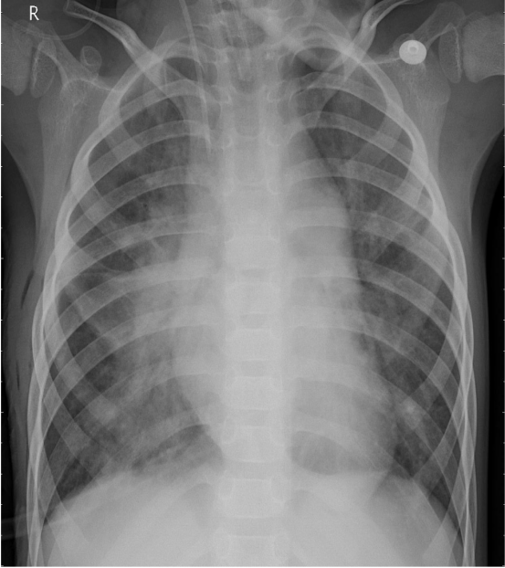

**6.3 DISTRIBUTION OF DATASET**

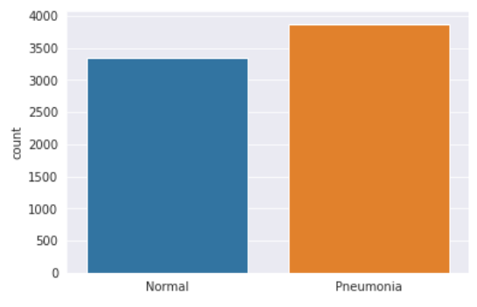

**6.4 LINE PLOT OF TRAINING AND VALIDATION LOSS**

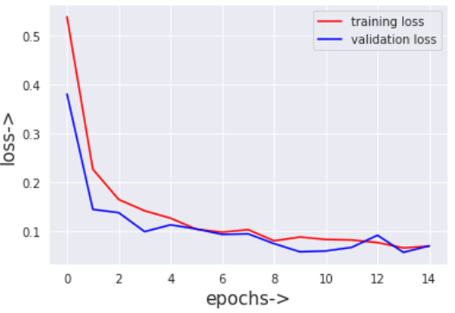

**6.5 LINE PLOT OF TRAINING AND VALIDATION ACCURACY**

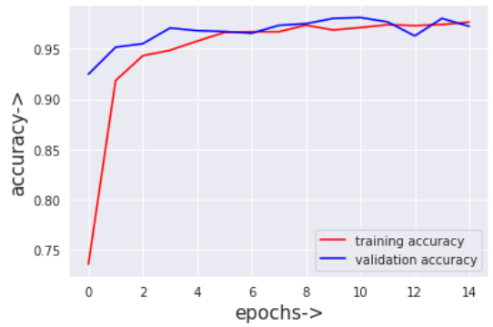

**6.6 TRAINING AND VALIDATION LOSS AND ACCURACY**



**REFERENCES**

1. **SOURCE CODE**

Soure code and python file is available here

<https://drive.google.com/drive/folders/1d7oIaI-4NnR16V03mff9Vsktp1__j7q9?usp=sharing>

1. **SCREENSHOTS**

We have to just pass the path of chest x-ray file in the Detect function.

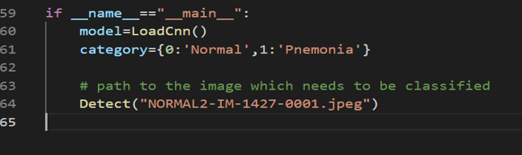

OUTPUT:

